**TIME SEER MANUAL**

Each persona in the time period, verbally describes the anomalies (and in some cases curses) to figure out the solution. You, as the Time-Seer need to refer to this and help them resolve the anomaly and break curses.

1. Consul - Praetor - Legatus - Tribunus Laticlavius - Legatus Pro Praetore - Legatus Augusti Pro Praetore - Praefectus Castrorum - Praefectus Alae- Tribunus Angusticlavius - Praefectus Auxilia
2. Often we ignore articles when taking a step, perhaps caught in the leap between space and earth. We know for certain though, how important the first letter in the alphabet is.
3. History is written on the second banner of stars. Stars correspond to the states.
4. Hazelnuts, wheat, silk, raisins, almonds, glassware, grapes,olive oil, figs, dates, garum (fish sauce), beer, sugar, honey

| **HIEROGLYPHS** | **READ AS** |
| --- | --- |
| 𓆑𓏏𓂋𓏏𓏲𓏏𓊵𓊨𓂀 | Power of Anubis |
| 𓆑𓂋𓏏𓊵𓊵𓊨𓂀𓏲𓏏 | Shadow of the Lost |
| 𓂀𓏏𓊵𓏏𓏲𓏏𓂋𓊵𓊨𓏏 | Blessing of Horus |
| 𓏏𓊵𓂀𓏲𓏏𓊵𓂀𓏏 | Path of Kings |

* Quintus Fabius Maximus Servilianus
* Quintus Marcius Rex
* Gnaeus Mallius Maximus
* Sextus Atilius Serranus
* Sextus Aelius Paetus Catus
* Sextus Julius Caesar

1. All good things come in 3s. The future thrives on balance. If AI can redefine its own rules, who is truly in control?
2. "IFF both the protectors become the threat, who remains safe?"

The clever engineers have created a mysterious value 'L' that must be decrypted to figure out correct clearance levels. To restore order, you must first uncover 'L' and let the errors reveal themselves.

| **Personnel Role** | **Encoded Clearance** |
| --- | --- |
| Authorized Personnel | L + 1 |
| Visitors | L - 1 |
| VIP Guests | L + 2 |
| Security Officers | L |
| Emergency Medical Response Team | L |
| AI Maintenance Technicians | L + 1 |
| Cybernetics Engineers | L + 1 |

| **Hieroglyph** | **Letter** |
| --- | --- |
| 🐦 (Reed) | A |
| 🌞 (Sun) | R |
| 🏺 (Jar) | W |
| 🦅 (Eagle) | A |
| 🔺 (Pyramid) | T |
| 🐍 (Snake) | S |
| 🌊 (Water) | N |
| 🏹 (Bow) | K |



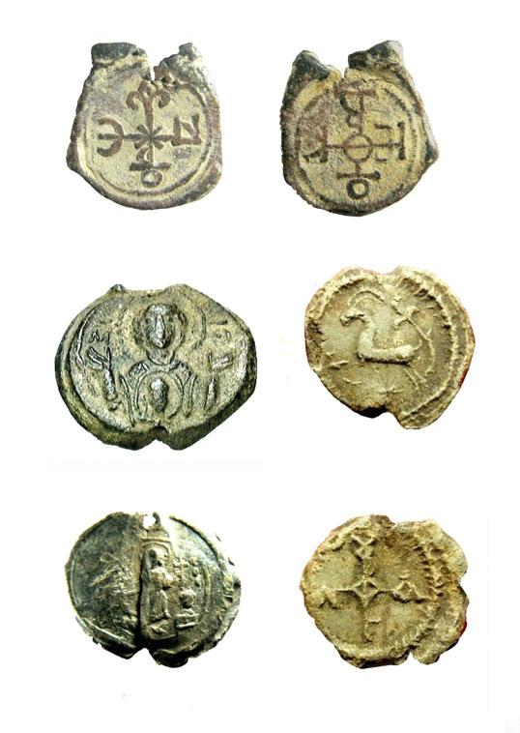

1. What repeats 3 is the founding of the city. Although 0 comes first, whatever repeats 3 is the founding of the cybernetic city.
2. In Egyptian mythology, constellations were associated with gods and the afterlife. Below is the **correct** star alignment, Some hieroglyphs/symbols can have two meanings/letters:

| **Egyptian Star Name** | **Corresponding Modern Constellation** | **Mythological Role** |
| --- | --- | --- |
| Sah | Orion | Represents Osiris, the afterlife god |
| Sepdet | Sirius | Associated with Isis, marks the Nile's flood |
| Meskhetiu | Big Dipper (Ursa Major) | The bull's leg, linked to divine rebirth |
| Duat Pathway | Milky Way | The river leading souls to the afterlife |
| Nebet | Pleiades | Symbol of the goddess Neith |
| Rekhyt | Cygnus (The Swan) | Sacred bird, guiding souls |

| misericordia (mercy)  videlicet (to wit; namely)  coram (in the presence of; before)  quondam (former; sometime; formerly)  punctatim (point for point)  partim (in part)  ana (in equal quantities)  secundum (according to)  ubique (everywhere)  vice (in place of; rather than)  quondam (former; sometime; formerly)  idem (the same word as mentioned before)  stillatim (drop by drop)  quoad (with respect to; as regards)  circiter (about; around)  secundum (according to)  quasi (as if; seemingly; in a manner)  semper (always)  ana (in equal quantities)  tempore (in the time of)  jure (by law)  subito (at once; immediately)  secus (otherwise)  variorum (including the notes of earlier scholars or editors)  et (and)  vulgo (commonly; popularly)  bis (twice; in two places) | item (likewise; also)  similiter (in a similar manner)  gregatim (in flocks)  vice (in place of; rather than)  seriatim (in succession; one after another)  punctatim (point for point)  versus (against; in contrast to)  remissio (forgiveness)  stillatim (drop by drop)  quatenus (in the capacity of; in so far as)  singillatim (singly)  versus (against; in contrast to)  remission  singillatim (singly)  sic (thus)  innocentem (not guilty, blameless; harmless)  punctatim (point for point)  quasi (as if; seemingly; in a manner)  quoad (with respect to; as regards)  passim (everywhere; dispersedly)  statim (immediately; at once)  singillatim (singly)  ubique (everywhere)  tempore (in the time of)  divisim (separately)  idem (the same word as mentioned before)  singillatim (singly)  libera (Free, Freedom)  pro (in favour of; for) |
| --- | --- |

1. The odd are even. The even is odd. Think binary. Odd numbers end with 1 and even numbers end with 0.

* Julius Caesar
* Augustus
* Tiberius
* Caligula
* Claudius
* Nero
* Galba
* Otho
* Vitellius
* Vespasian
* Titus
* Domitian

1. Compare alpha and numeric for the launch.

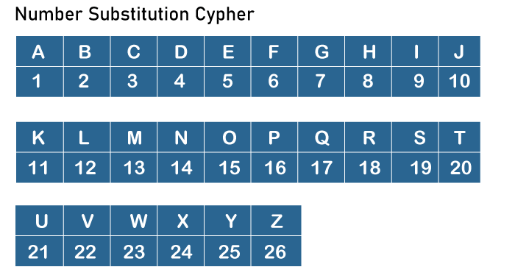

1. 10% is 80,000 extra fuel. Add and compare the existing. 80,000+800,000 should be >= 950,000. Add fuel with the addition doesn't add up
2. Swap the cursed numeric first and last, now add a decimal point before the new first and finally mirror the new 2nd direction.
3. The **cybernetic future** never moves backward—watch the timeline.
4. Just because something looks different doesn’t mean it is an error. Sometimes, the real anomaly of the future is enormously hiding in plain sight.

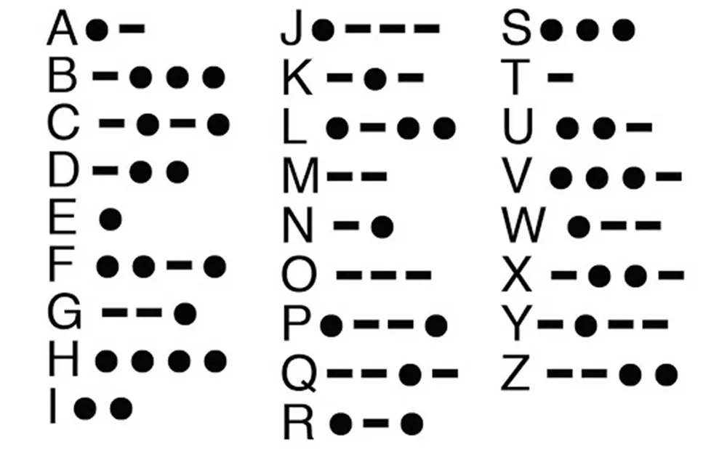

| **Hieroglyph Name** | **Meaning** | **Correct Star Alignment** | **Hint from the Time Seer** |
| --- | --- | --- | --- |
| **𓂀𓏏𓊵(Ra)** | The Sun God | **Sepdet (Sirius)** | "The light that rises and sets, leading the way." |
| 𓆣𓏏𓏲𓊵 (Osiris) | Lord of the Underworld | Duat Pathway (Milky Way) | "The one who walks the river of souls, unchanging in the night." |
| 𓅃𓏏𓊵𓊵 (Horus) | The Falcon God | Sah (Orion) | "The wings that soar high, forever watching from above." |

The player must determine which **god’s name aligns with which constellation** in the sky. In the celestial prophecy, the god’s name is said along with its star alignment.

| **Hieroglyph** | **Transliteration** | **Meaning** |
| --- | --- | --- |
| 𓂀 | ir | Eye of Ra / Protection |
| 𓏏 | t | T sound / Feminine suffix |
| 𓊵 | ḏr | Rest / Sleep / Sacred place |
| 𓏲 | w | Plural / Phonetic complement |
| 𓊨 | ḥtp | Eternity / Resting place |
| **☀** | Ra | Sun / God Ra |

1. **Memory timelines** for AI laws must be precise; dates determine the order of history.

| **Hieroglyph Symbol** | **Corresponding Letter** | **Description** |
| --- | --- | --- |
| 𓄿 | A | Vulture |
| 𓃀 | B | Foot |
| 𓍿 | C | Pool of Water |
| 𓆑 | D | Horned Viper |
| 𓎼 | E | Cobra |
| 𓎡 | F | Basket |
| 𓆓 | G | Cobra |
| 𓎛 | H | Twisted Flax |
| 𓇋 | I | Reed |
| 𓏭 | J | Double Reed |
| 𓎡 | K | Basket |
| 𓃭 | L | Lion |
| 𓅓 | M | Owl |
| 𓈖 | N | Water Ripple |
| 𓍹 | O | Ring with Cross |
| 𓊪 | P | Mat |
| 𓏘 | Q | Hill Slope |
| 𓂋 | R | Mouth |
| 𓋴 | S | Bolt of Cloth |
| 𓏏 | T | Bread |
| 𓅨 | U | Quail Chick |
| 𓍯 | V | Lasso |
| 𓏲 | W | Reed with Quail Chick |
| 𓐍 | X | Folded Cloth |
| 𓊃 | Y | Door Bolt |
| 𓏭 | Z | Double Reed with Zigzag |

1. Some hieroglyphs/symbols can have two meanings/letters.

| **Hieroglyph** | **Meaning** |
| --- | --- |
| ☀ | Sun/**Ra** |
| 🌊 | Water/Nile |
| 🔲 | **Gate**/Portal |
| 🏺 | Jar/Offerings |
| 🗿 | Statue/Pharaoh |
| 🔺 | Pyramid |
| 🕊 | Harmony/**Peaceful** |
| 🦅 | Falcon/Horus |
| 👁‍🗨 | Eyes/**Souls** |
| 🔒 | **Seal**/Protect |
| ✨ | Light/Illumination |
| 👑 | Afterlife/**Osiris** |
| ⏳ | **Sands**/Time |
| 🐺 | Jackal/**Anubis** |
| 🏹 | **Guide**/Direct |
| 🚪 | **Door**/Barrier |
| 🛑 | **Close**/Stop |
| 🌬 | **Winds**/**Breath** |
| ⚰ | Rebirth/**Death**/Skull |
| ☥ | Ankh/Eternal Life |
| 🐍 | Snake/Set/Chaos |
| ⚖️ | Scales/Balance/ Ma’at/Judgment |
| 🔥 | Flames/Destruction |